Table of Contents

introduction 2

Turtle Hatcheries in Sri Lanka 2

Designs 3

INDEX PADE 3

Index page design in Website 4

HOMEPAGE 5

Home page design on Website 6

CATEGORY PAGE 7

Category page in the Website 8

ABOUT US PAGE 8

About Us page in the Website 10

THREATS PAGE 12

OTHER HATCHERIES PAGE 14

BENTOTA TURTLE HATCHERY PAGE 16

KOSGODA TURTLE HATCHERY PAGE 18

DONATE PAGE 20

# introduction

### Turtle Hatcheries in Sri Lanka

Turtles around the countries are rescued and are taken care of by turtle hatcheries and other turtle protection research centers to prevent the extinction of sea turtle’s and to reduce the number of turtles who are victimized every year due to the actions done by humans and the phenominal changes happening around the globe. This following report follows a website about turtle hatcheries in Sri Lanka and their information.

# Designs

## INDEX PADE

### Index page design in Website

## HOMEPAGE

### Home page design on Website

## CATEGORY PAGE

v

v

v

### Category page in the Website

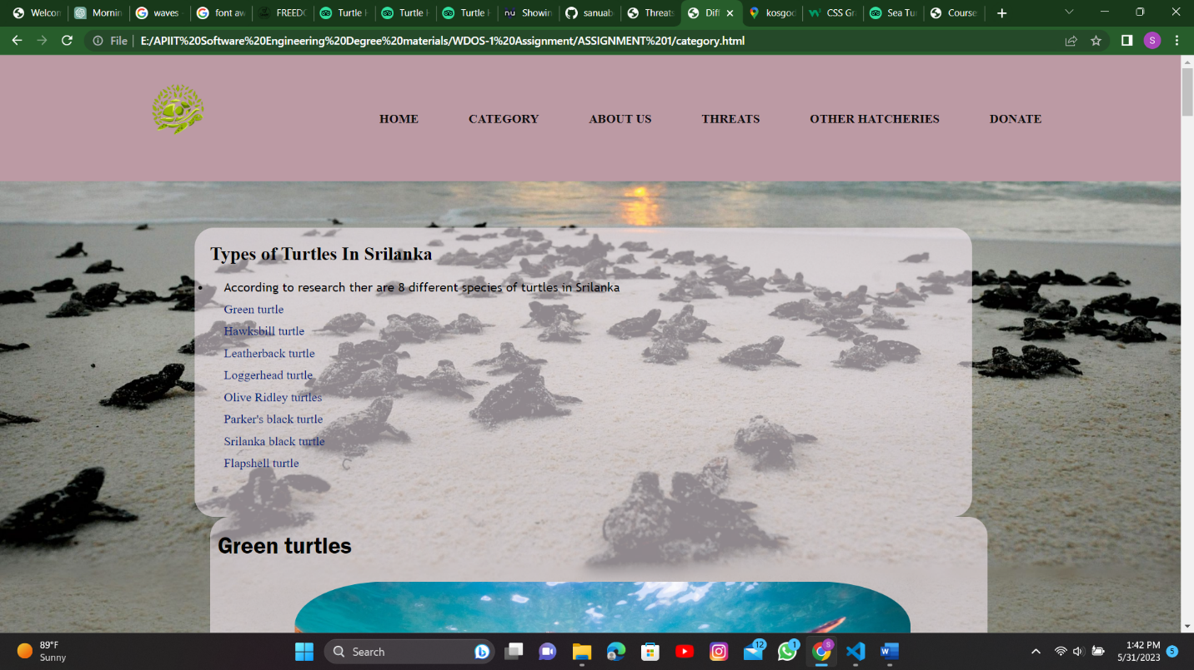

## ABOUT US PAGE

v

v

v

v

### About Us page in the Website

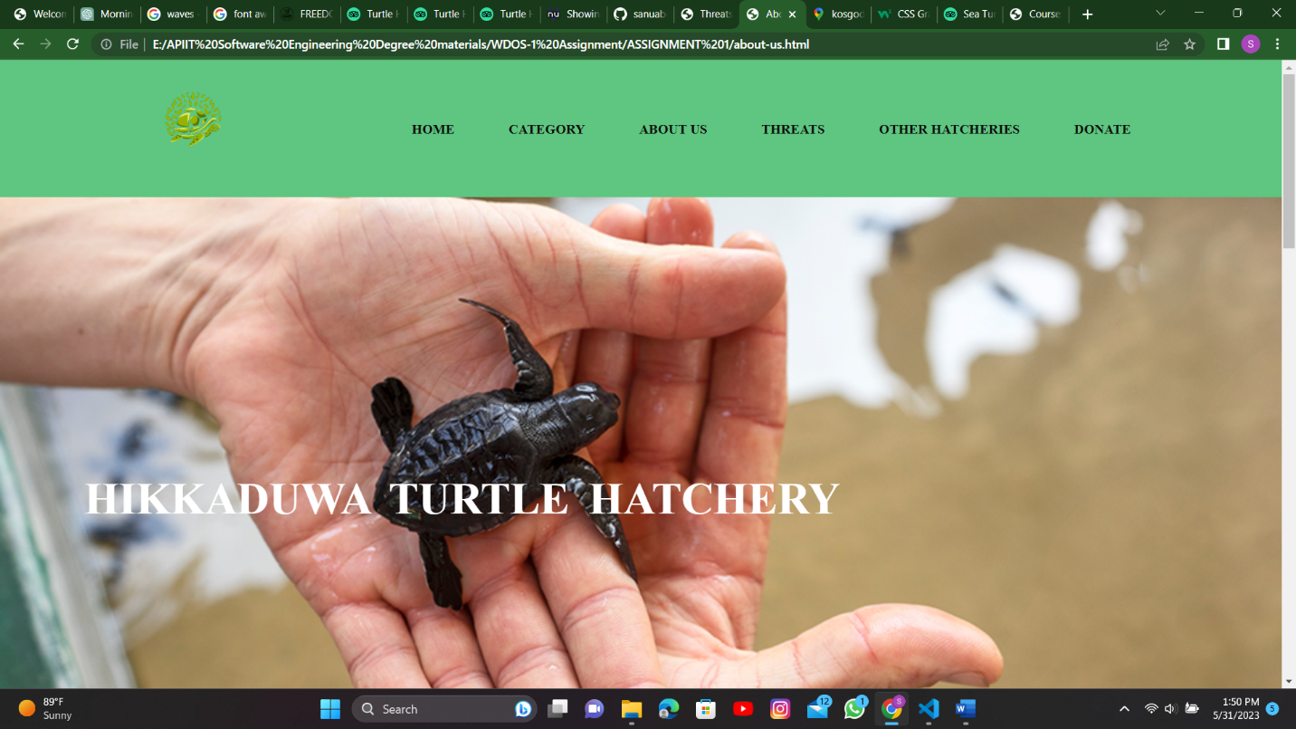

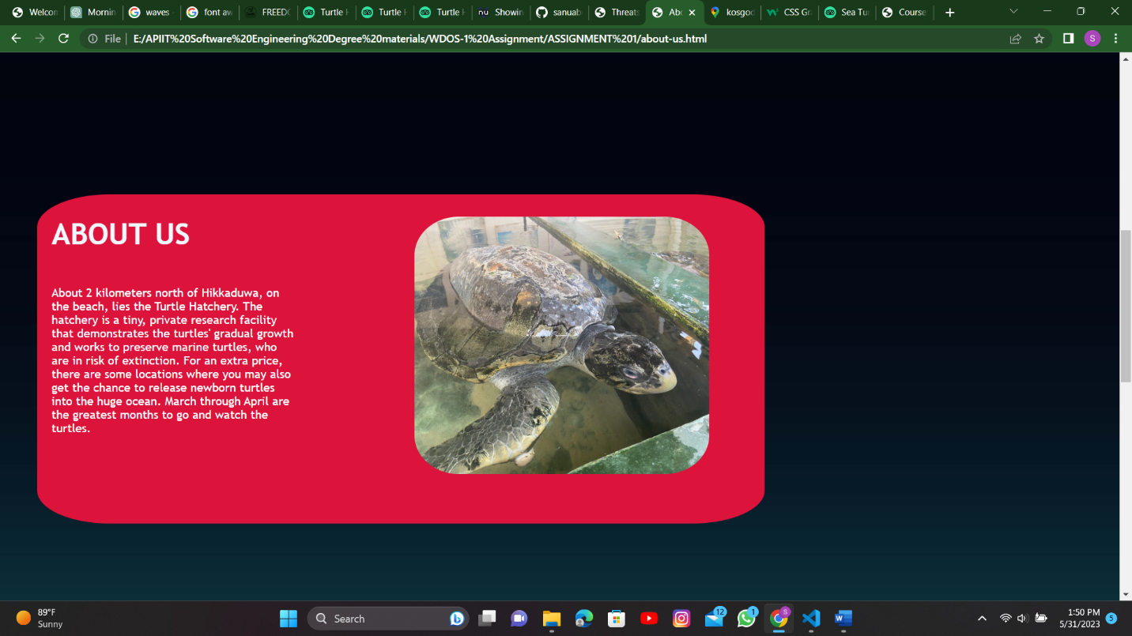

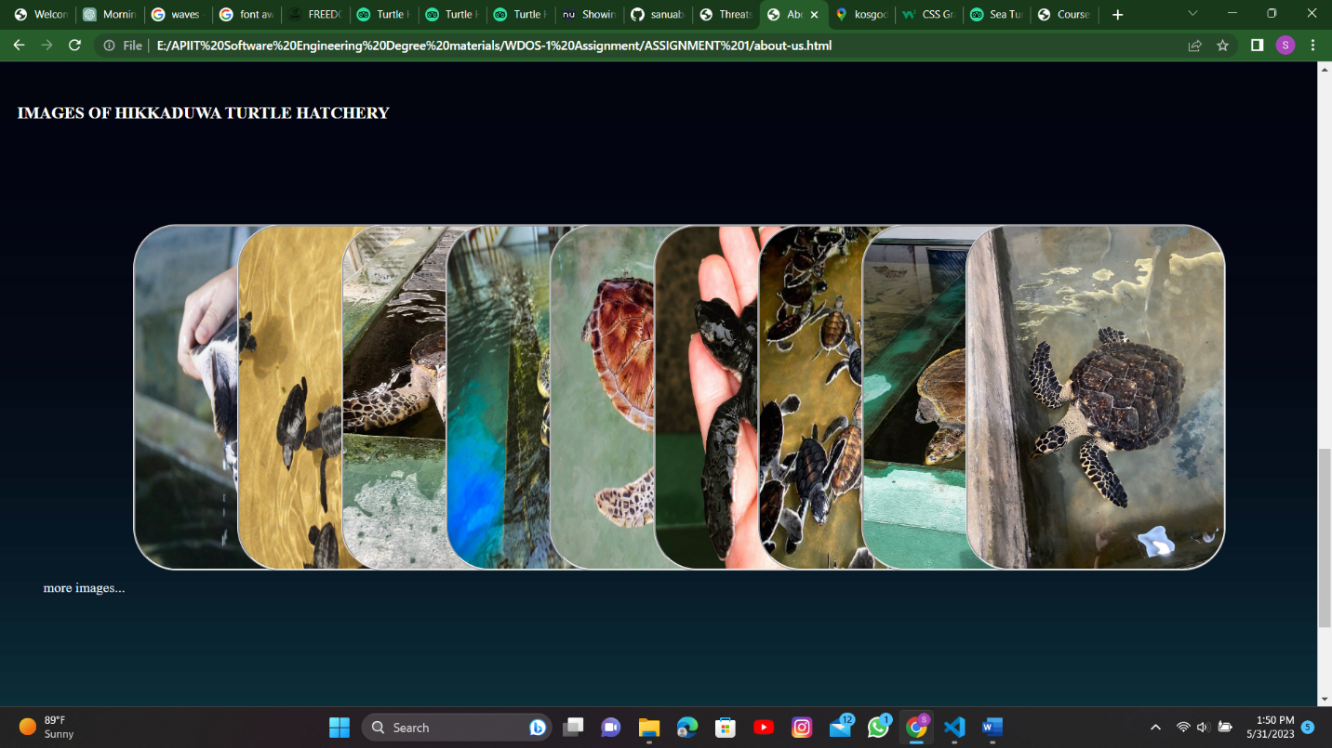

## THREATS PAGE

## OTHER HATCHERIES PAGE

## BENTOTA TURTLE HATCHERY PAGE

## KOSGODA TURTLE HATCHERY PAGE

## DONATE PAGE

v

# Validation Screenshots